Stuck at home?
Things you can do if you can’t go out:
Covid 19 has caused a major disruption to our everyday lives.

With schools and day services closed and restrictions on everyone’s ability to get out and about, there are big changes in our everyday lives and our routines.

Cope Foundation Occupational Therapy Department has put together this collection of activity ideas that you may find useful.

Some things may suit; others may not so pick and choose what works for you and those you are supporting.

Things to Consider
- Establish a daily routine considering the activities that are most meaningful to the person
- Balance your weekly routine so you have a good mix of work (activities that have to be done), rest and leisure
- Try to keep to normal waking and sleeping hours
- When offering a choice of activities, limit choice to 2 or 3 activities

Please contact the OT department on 021-4643278 or 021-4643333 if you have any concerns or require support.

Helping out with Daily Living Activities

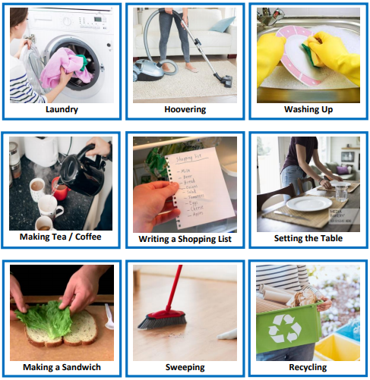
- Learn to cook with Cookability: https://www.youtube.com/playlist?list=PLl79ZsuMB5bYbVZduF8_-jl_fPwpMqsCv

- Bake Bread/ scones to experience deep pressure touch (calming) https://www.youtube.com/watch?v=YZH0iKMrXTI

Exercise and Outdoors
Physical Education (P.E.) with Joe Wicks (The Body Coach) on YouTube: https://www.youtube.com/playlist?list=PLyCLoPd4VxBvQafyve889qVcPxYEjdSTl  Special Olympics Online School of Strength https://www.specialolympics.org/school-of-strength | 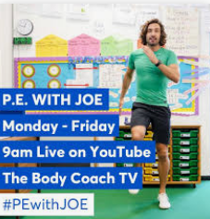  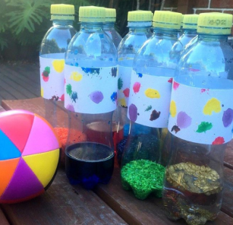  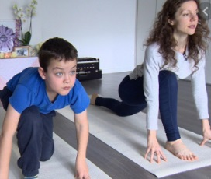
Daily Activities to do on your walk: https://www.mencap.org.uk/sites/default/files/2020-04/Mencap_activities%20for%20your%20daily%20walk.pdf
Yoga for people with complex needs: http://pamis.org.uk/news/postural-care/yogability-at-home/
Cosmic Kids Yoga: Online yoga videos https://www.youtube.com/user/CosmicKidsYoga
To slow YouTube clips down:
1. Open the video in You Tube.
2. Click the three dots in right hand corner or settings icon on the bottom right. 3. Select ‘playback speed’ to 0.5x or less.
Go Noodle: online movement and mindfulness videos for children https://www.youtube.com/channel/UC2YBT7HYqCbbvzu3kKZ3wnw
Home-made Sensory Skittles https://www.hometalk.com/14513931/indoor-outdoor-recycled-sensory-bowling-skittles

Creative and Sensory Activity Ideas
Arts for all: The Department of Arts and Creative Arts Therapies have been working on how we can support you and the people we support remotely through creativity and connection both at home and in our residential services. https://www.artsforall.ie/events-and-activities-calendar
Grow your own grass head https://www.homemade-gifts-made-easy.com/grass-heads.html | 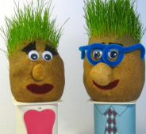
Painting faces on rocks https://paint.linkiim.com/paintingideas/painted-rock-faces | 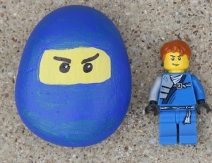
Chalk drawings on patio/ path (Art, marking out trails or make a movement game!) https://richard-t.com/18-sidewalk-chalk-art-ideas/
Sensory bottles  https://www.youtube.com/watch?v=QU1gXEKb90o | 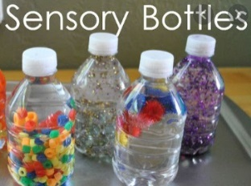
Sensory Spectable: Sensory play and activity ideas: online video demonstrations  https://www.facebook.com/sensoryspectacle/videos/ | 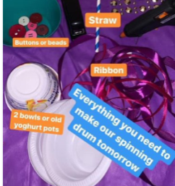
Making SENse Creative Services Ltd Facebook page provides daily videos of sensory art activities using items that should be relatively easy to source. https://www.facebook.com/sensorycreativeMakingSENse/  Written instructions available: http://pamis.org.uk/site/uploads/judys-sensory-ideas.pdf | 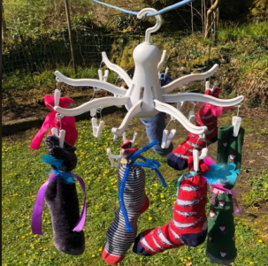

Mindfulness and meditation  Use music, lighting, room layout, to create a calm space for mindfulness and relaxation. https://asiam.ie/creating-a-quiet-space/  Twinkl website have several activities which are free at present; these include Mindfulness colouring sheets https://www.twinkl.ie/ | 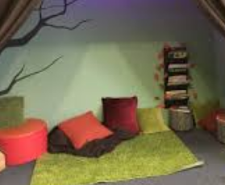
Reminiscence  - Create a life story book with pictures, notes etc.,  - Create a photobook online (free prints, our story app),  - Document quarantine-take pictures and keep a daily diary.  - Memory box  https://www.ntdc.ie/wp-content/uploads/2020/04/2020-Covid-19-time-capsule-sheets.pdf  https://www.ntdc.ie/wp-content/uploads/2020/04/2020-COVID-19-Time-Capsule-For-Adults-EN-US-1.pdf | 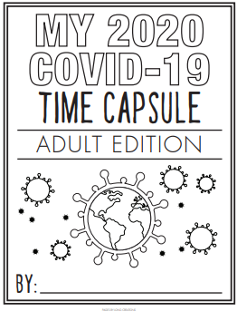
Games:  Jenga, Bingo, Chair golf, Guess Who (could be customized) | 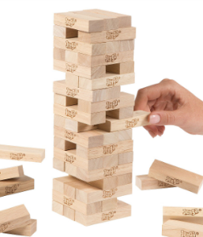
School Closure Kit : Gross Motor Classes and Fine Motor Activities  https://myotandme.com/ | 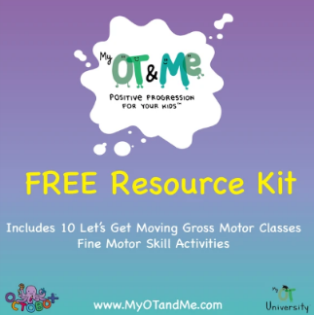

Links to Activities Online
- View a live Safari: https://wildearth.tv/safarilive/
- Viewing animals in 3D through your phone:
- Type into Google search bar what animal you want to see, e.g. lion, penguin, bear
- Google will bring up a box asking ‘Meet a life-sized Lion up close.’
- Click ‘view it in 3D’ to see the animal.
- Look at the Animals at Dublin Zoo: https://www.dublinzoo.ie/animals/

- News from NASA: https://www.youtube.com/watch?v=ME3IjrDU4PY

Mencap TV: learning disability ambassadors have been creating videos to help you beat the boredom and stay active, including dance fitness, healthy eating tips and exercise videos.
https://www.youtube.com/playlist?list=PLEG4ZKDX2p9lWNhyX7isrvFXxohxXxnb-
Play an Online Game  - Download an app to your smartphone or tablet; e.g. Real Bowling 3D. https://apps.apple.com/gb/app/real-bowling-3d-by-eivaagames/id1006196558  Quick Draw: https://quickdraw.withgoogle.com/ | 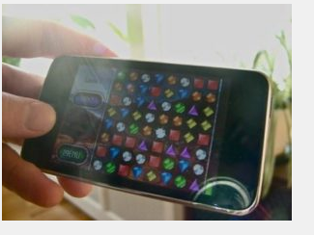
Andrew Lloyd Webber’s biggest musicals are streaming free on YouTube for a limited time during COVID-19 https://www.youtube.com/channel/UCnVSzQ6rME82AzW1ctGcO_g | 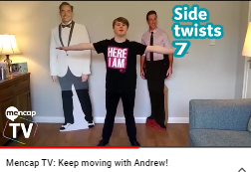
Disney are offering free virtual tours and rides
https://orlandoonthecheap.com/free-virtual-rides-disney/

- Sproutflix is offering 3 free films each week, featuring people with intellectual and developmental disabilities.
http://sproutflix.org/virtual-sprout-film-festival-413-2020/

Accessible Chef -
Accessible Chef is a collection of free visual recipes and other resources to help teach cooking skills to individuals with disabilities.

- https://accessiblechef.com/

Apps for People with Autism
Wait timer Visual timer tool €3.49  Or  Visual countdown - Duck (free) | 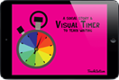
Choice works €7.99
Set up Visual schedules - morning, night, school etc
Kids Activity Clock € 1.09  -can let your child see a visual display of scheduled activities. | 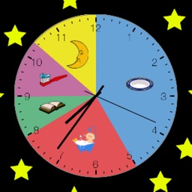
Turn Taker social story and sharing €3.49  -Turn Taker uses visual and audio cues to facilitate turn taking and sharing for any child. | 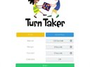
Zones of regulation €6.99
-The app helps students gain skills in consciously regulating their behaviors to the social and environmental demands.
Idress for weather €2.29
- iDress helps children and adult to choose appropriate clothes depending on the weather.
I touch i learn life skills: morning routine €2.29  - Helps set up a visual schedule for morning routine | 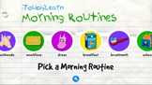
Dexteria – Fine Motor Skills Development €6.99
- Dexteria -- Fine Motor Skill Development is an exercise app for the hands and fingers of young kids, or older kids with special needs
Snap type €5.49 (free version available)  - SnapType helps children/adults to easily complete worksheets/schedules/crosswords with the help of a phone or tablet. | 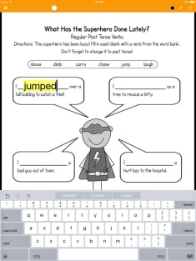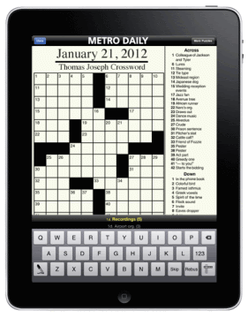
Activity Tracker (free)  Tracks steps and progress | 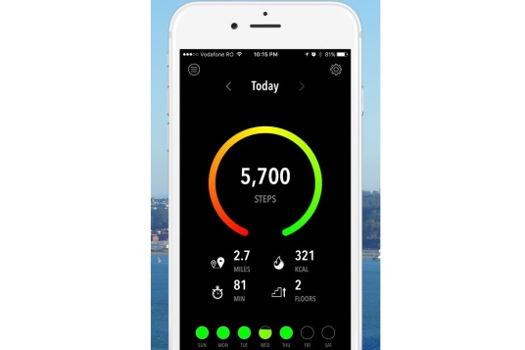
CanPlan (free in app purchases)
-CanPlan promotes independence and builds confidence by helping people to complete tasks successfully.
Calm app (free)
-help users sleep better, boost confidence and reduce stress and anxiety, all with the help of guided meditations, soothing music, and bedtime stories

